Exp. No.: 20

**MYSQL STRING FUNCTIONS- REPLACE, REPEAT, REVERSE, RIGHT, LEFT, RPAD, LPAD**

**AIM:** To implement Replace, Repeat, Reverse, Right, Left, Rpad and Lpad String Functions using MySQL

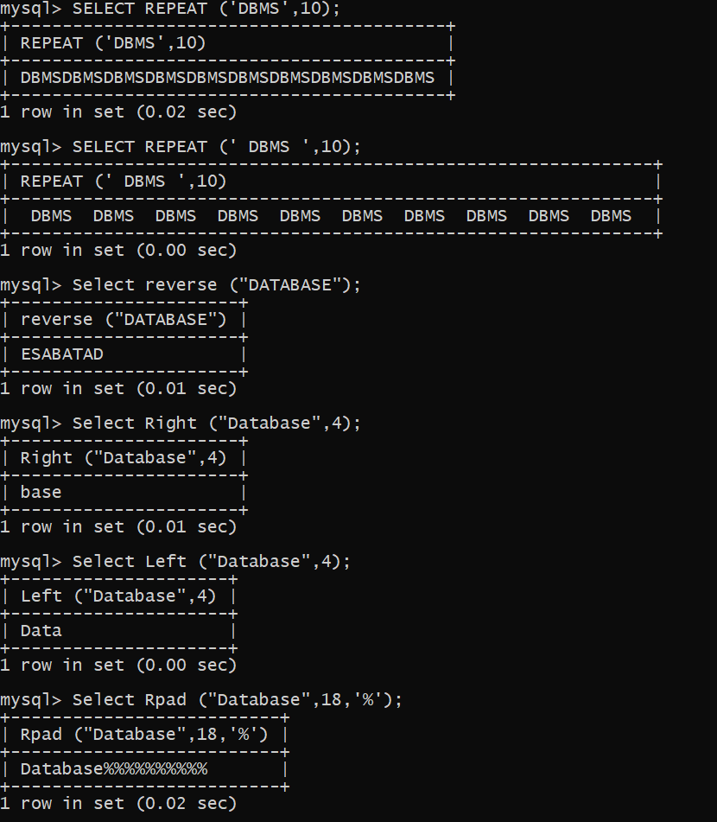

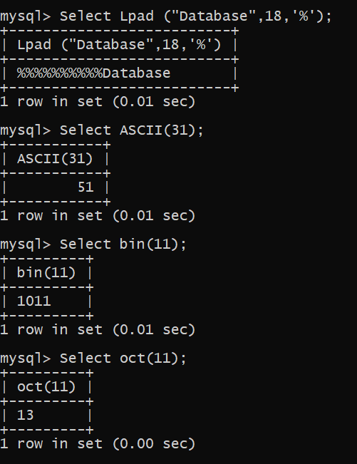

**RESULT**

Thus the String Functions such as Replace, Repeat, Reverse, Right, Left, Rpad and Lpad are executed successfully.